**PETSHOP MANAGEMENT SYSTEM**

* **ABSTRACT**

Pet shop management system (PSMS) will handle t he animal’s record, pet shop management e- commerce My SQL. The users can view various pets up for sale record. Admin can manage the orders and the pets. it has many functionalities such as admin panel for management of pets and categories and orders and cart functionalities. The system stores and manages data about Pet, sales, customer and inventory. It also generates reports and queries for decision making. The project uses a relational database model and the waterfall methodology. The project shows how SQL can create and manipulate databases effectively.

* **AIM OF PROJECT**
* The main aim of the project is pet shop management system project is to make transactions and deals with customers in a more pleasant and efficient manner by simply gathering information from them. Using SQL those data save and increment data.
* **INTRODUCTION**

In this modern world everything can be controlled and accessed without the presence of a particular person- that which the time constraint of the modern world demands. This concept is implemented in a complete way through the Pet Management. It is not practical in today’s life to spend much time only being dedicated for a particular work Admin can manage the orders and the pets. it has many functionalities such as admin panel for management of pets and categories and orders and sale information create by SQL table. sed. The type given to the pet's owner must meet all essential conditions, including the name of the owner, the pet's name, the breed, date of birth and colour. Pet shop management system (PSMS) will handle the animal’s record, pet shop management e- commerce MYSQL application. The users can view various pets up for sale and can add to Data and create table.

* **OBJECTIVE OF PROJECT**
* The brief introduction about the backend software SQL.
* To generate various reports and queries to support the decision making of the Pet and customer list
* To track the information about sold pets and products to a customer.
* To provide an option for storing and managing the basic information about the customer.
* To provide an option for storing and managing the basic information about pets and pet products in the shop.
* To document the system to testing process, objectives and the test cases are tested and the expected results with the observed results are written with the result.

**ER DIAGRAM**

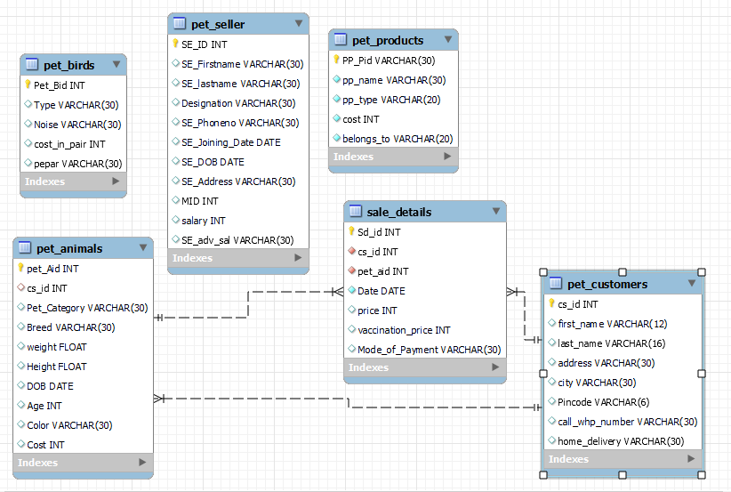

**STRUCTURE OF TABLE’S**

* **CUSTOMERS**

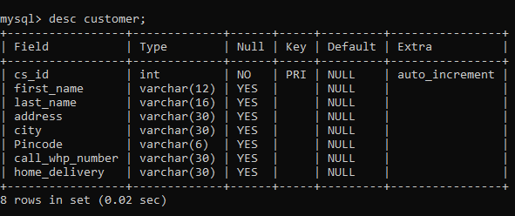

* **PET PRODUCTS**

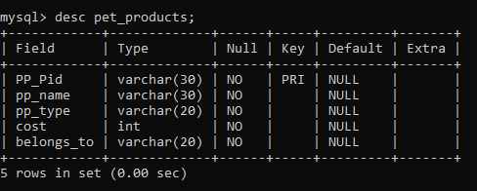

* **PET BIRDS**

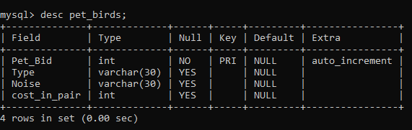

* **PET SALES DETAILS**

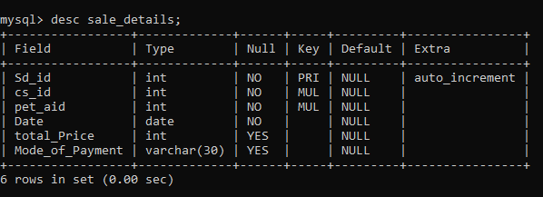

* **PET ANIMALS**

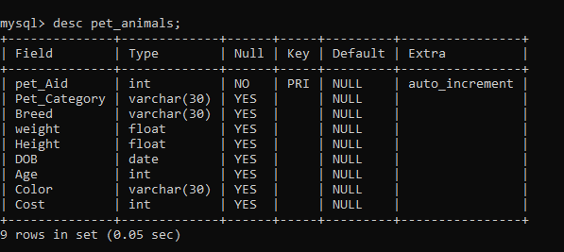

* **PET SELLER**

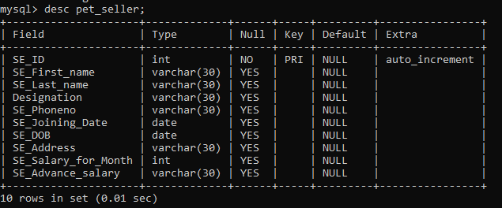

**CONTENT OF TABLE’S**

* **PET CUSTOMER**

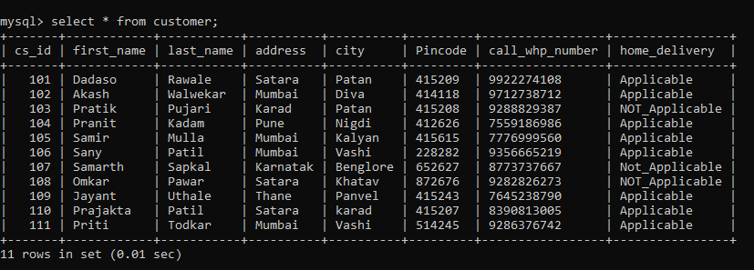

* **PET PRODUCTS**

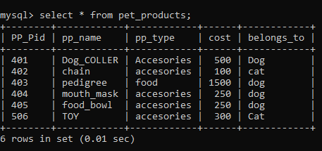

* **PET BIRDS**

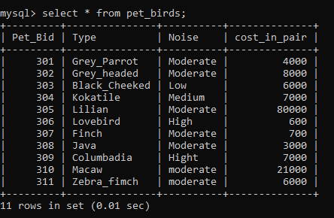

* PET SALE DETAILS

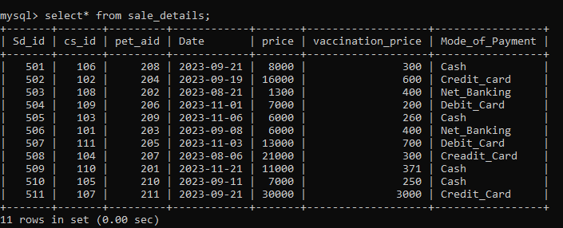

* 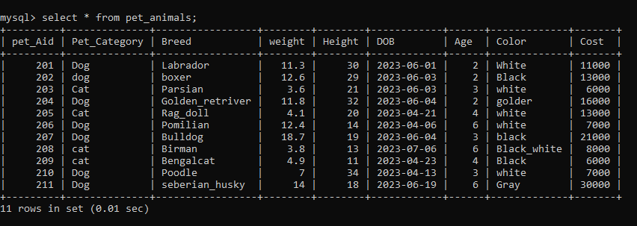**PET ANIMALS**
* **PET SELLER**

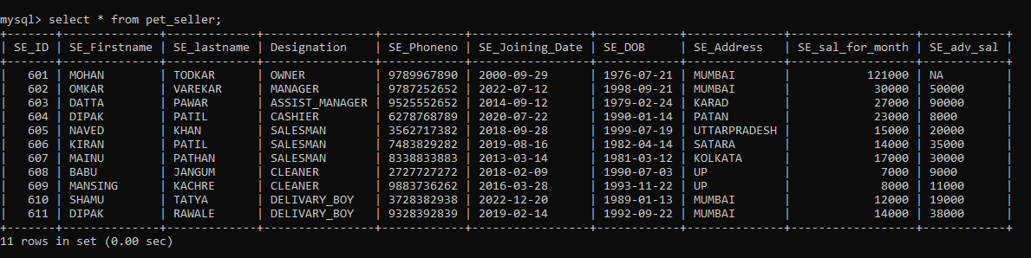

**OPERATOR’S**

* **ARITHMETIC**
* **ADDITION (+)**
* QUESTION = Display the details of pet who has total price of the sale the pet using arithmetic op?
* **Query = select sd id , cs id, pet aid ,price+ vaccination price as total from sale details;**

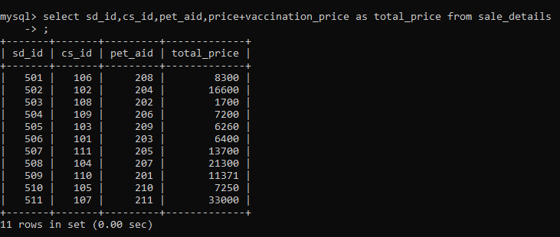

* **SUBTRACTION (-)**
* **QUESTION= Customers who purchase a pet receive a special discount? display it.**
* **Query= select sd_id,cs_id,pet_aid,price-500 as special discount from sale details;**

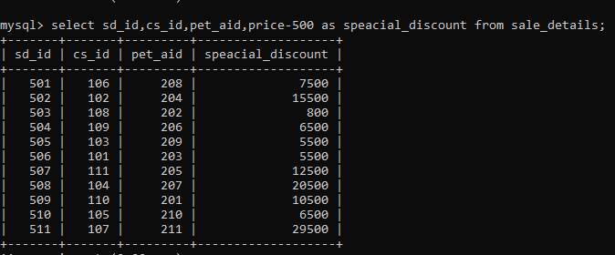

* **MULTIPLICATION (*)**
* **QUESTION=**display the details use arithmetical to show how much the seller person earn annually**?**
* **Query=** **select se first name, se last name se salary for month*12 as annual salary from pet seller;**

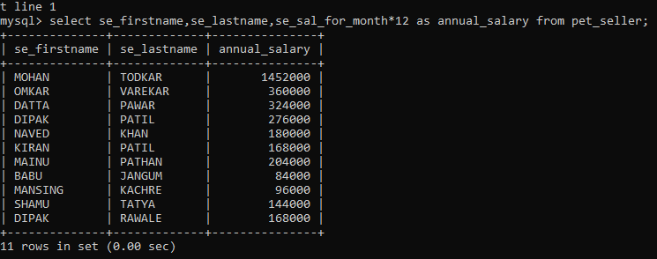

* **DIVISION (/)**
* QUESTION= display the details use arithmetical to show how much the seller person earn one day?
* Query= select se first name se last name se salary for month/30 as per day salary from pet seller;

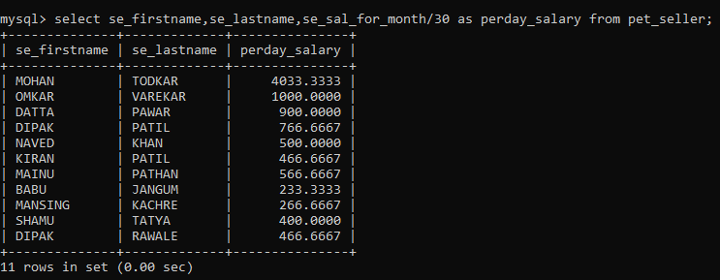

* **COMPARISON**
* **{LESS THAN (<)}**
* **QUESTION=Display the details of PET ANIMAL who has cost less than 10000?**
* **Query=select * from pet animals where cost<10000;**

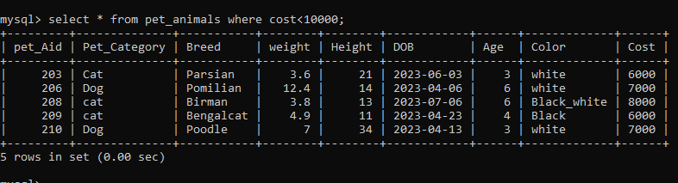

* **{GREATER THAN (>)}**
* **QUESTION= Display the details of PET ANIMAL who has cost Greater than 10000?**
* **Query=select * from pet animals where cost>1000;**

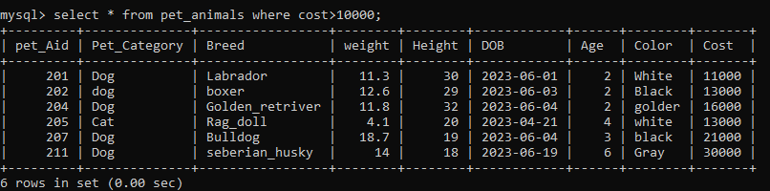

* **{ LESS THAN OR EQUAL TO (<=) }**
* **QUESTION=Display the details of PET seller whose salary is less than equal to 7000.**
* **QUERY=select * from pet seller where se salary for month<=7000;**

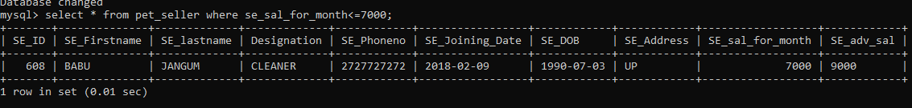

* **{GREATER THANE OR EQUAL TO (>=)}**
* **QUESTION=Display the details of pet product whose cost is Greater than or equal to 100.**
* **QUERY=select * from pet product where cost>=100;**

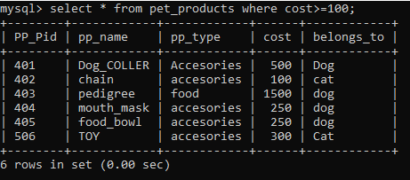

* **{EQUAL TO (==)**
* **QUESTION= Display the details of pet CUSTOMER whose FIRST NAME IS PRAJKTA.**
* **QUERY=select * from pet customers where customer first name=PRAJAKTA;**

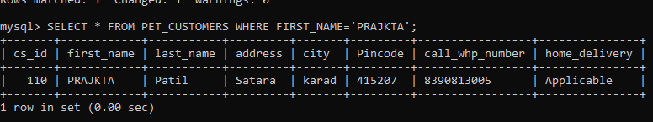

* **{NOT EQUAL TO (! =)}**
* **QUESTION= Display the details of pet animals not show cat data.**
* **QUERY=select * from pet animals where pet category ! =’cat’;**

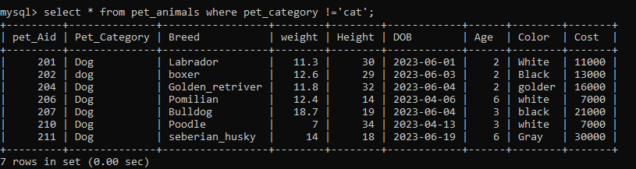

* **LOGICAL OPERATOR**
* **AND OPERATOR**
* **QUESTION=** **Display the details of Pet seller who is working as ‘salesman’ and have salary more than 7000.**
* **QUERY=select * from pet seller where designation =’salesman’ and se salary for month>7000;**

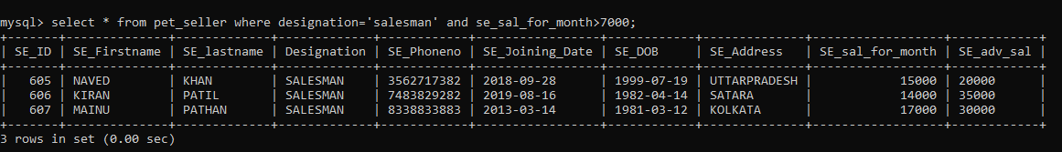

* **OR OPERATOR**
* **QUESTION=** **Display the details of Pet shop who is working either as a ‘CLEANER’ or ‘CASHIER’**
* **QUERY=Select * from pet seller where designation=’cleaner’ or designation=’cashier’;**

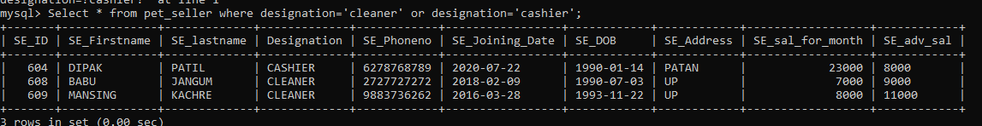

* **RANGE**
* **QUESTION=** **Display the details of pet shop whose salary is Between 7000 to 20000.**
* **QUERY= select se id se first name se last name designation se salary for month from pet seller where se salary for month between 7000 and 20000;**

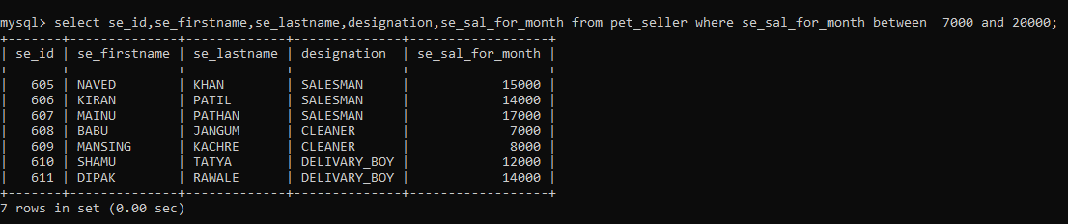

* **QUESTION=** **Display the details of pet shop whose pet product price is Between 100 to 298.**
* **QUERY=select * from pet product where cost between 100 and 289;**

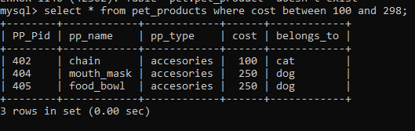

* **LIKE**
* **QUESTION=** **Display the details of pet customer whose name starts with S.**
* **QUERY=select * from pet CUSTOMERS WHERE FIRST NAME LIKE(‘S%’);**

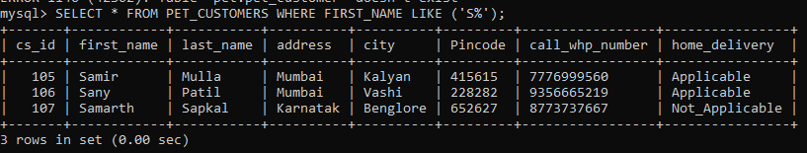

* **QUESTION=** **Display the details of pet animals whose born pet the month of June?**
* **Query=** **select * from pet animals where DOB like (‘%__6__%’);**

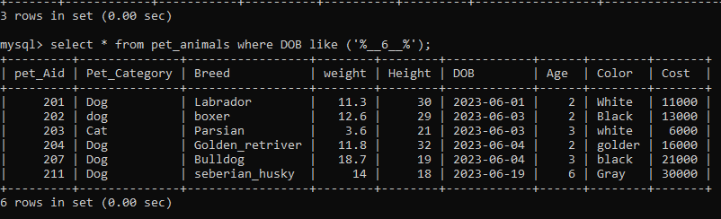

* **IN(LIST)**
* **QUESTION=** **Display the details of Pet customer whose name is “OMKAR”, “SAMIR”, “PRANIT”, “PRATIK”.**
* **Query= SELECT * FROM PET CUSTOMERS WHERE FIRST NAME IN (“OMKAR”,”SAMIR”,”PRANIT”,”PRATIK”);**

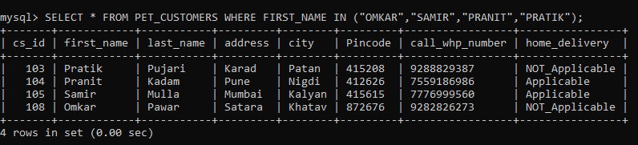

* **QUESTION=** **Display the details of Pet customer whose name is “LOVEBIRD”, “LILIAN”, “FINCH”, “JAVA”.**
* **Query= SELECT * FROM PET BIRDS WHERE TYPE IN (“LOVEBIRD”, “LILIAN”, “FINCH”, “JAVA”);**

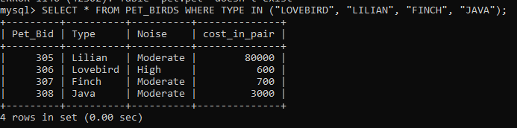

**AGGREGATE FUNCTION’S**

* **MIN ()**
* **QUESTION=** Display the Minimum cost of the bird.
* **QUERY=**select min(cost) from pet birds;

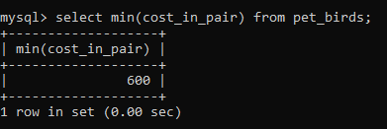

* **MAX ()**
* **QUESTION=** Display the Maximum cost of the bird.
* **QUERY** = select max(cost) from pet birds;

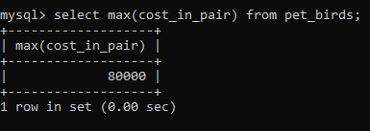

* **SUM ()**
* **QUESTION==** Display the Total price of all pet animals.
* **QUERY=**select sum(cost) from pet animals;

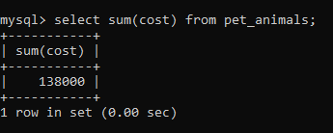

* **AVG ()**
* **QUESTION=** Display the pet average cost of the bird.
* **QUERY=** select avg(cost in pair) from pet birds;

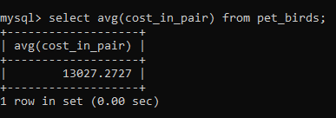

* **COUNT ()**
* **QUESTION=** Display the total count of pet animals?
* **QUERY= SELECT COUNT (*) FROM OET ANIMALS;**

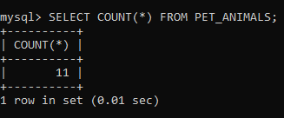

**CLAUSE’S**

* **WHERE CLAUSE**
* **QUESTION=Display the details of all the pet seller who earn more than the average salary**
* **QUERY=select se id , se first name, se salary for month pet seller where se salary for month>(select avg (se salary for month) from pet seller;**

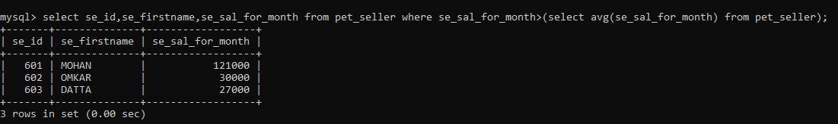

* **GROUP BY CLAUSE**
* **QUESTION=Display the PP TYPE, PP NAME of pet product type in each product name where there should be at least type=’ACCESORYES’ in each product name.**
* **QUERY=SELECT PP TYPE, PP NAME, FROM PET PRODUCT WHERE PP TYPE=’ACCESSORIES’ GROUP BY PP NAME;**

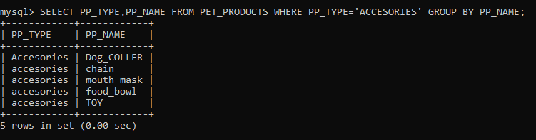

* **HAVING CLAUSE**
* **QUESTION=display max salary of pet seller for each advance salary where max salary should be greater than or equal to 10000?**
* **QUERY=select max(sal),se adv sal from pet seller group by se abv having max(sal)>=1000;**

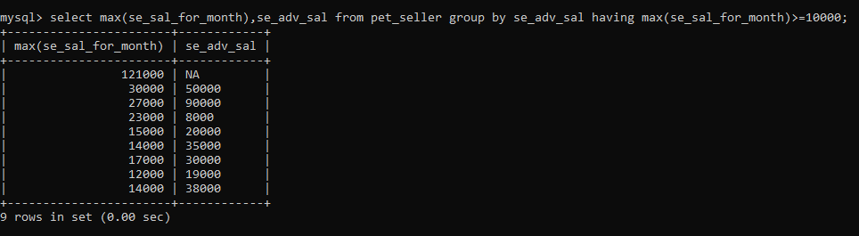

* **ORDER BY CLAUS**
* **ORDER BY**
* **QUESTION= Display the details of PET BIRDS what the order by noise?**
* **QUERY=select * from pet birds where order by noise;**

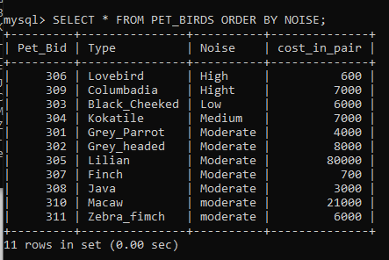

* **DESCENDING ORDER**
* **QUESTION=** **Display the details of pet shop what are pet sale date for descending order?**
* **QUERY=select * from sale details where date order by date desc;**

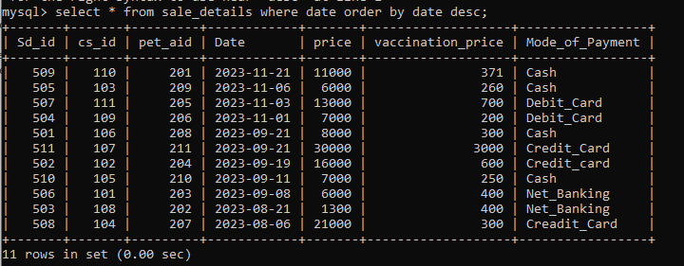

* **ASCENDING ORDER**
* **QUESTION= Display the details of pet CUSTOMERS what are first name whose name contain ‘A’ for ASCENDING order?**
* **QUERY=select * from pet customers where first name like’(%A%’) order by first name asc;**

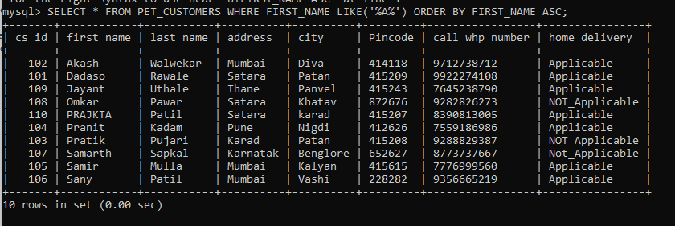

* **LIMIT CLAUSE**
* **QUESTION=DISPLAY the first three row in the customers table?**
* **QUERY=select * from pet customers limit 3;**

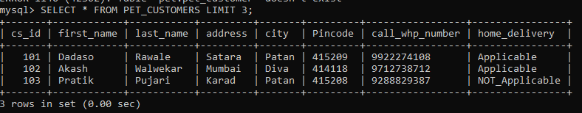

* **QUESTION=Display the remaining four rows except the first three rows in the customer table?**
* **QUERY=select * from pet customer limit 3,4;**

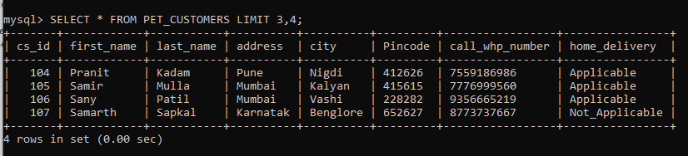

**JOIN’S**

1. **INNER JOIN**

* **QUESTION=Display the details of pet animals and pet sale details those table to join using inner joint.**
* **QUERY= select p.cs_id,p.pet_category,p.breed,p.color,s.date,s.mode_of_payment from pet_animals p inner join sale_details s on p.cs_id=s.cs_id;**

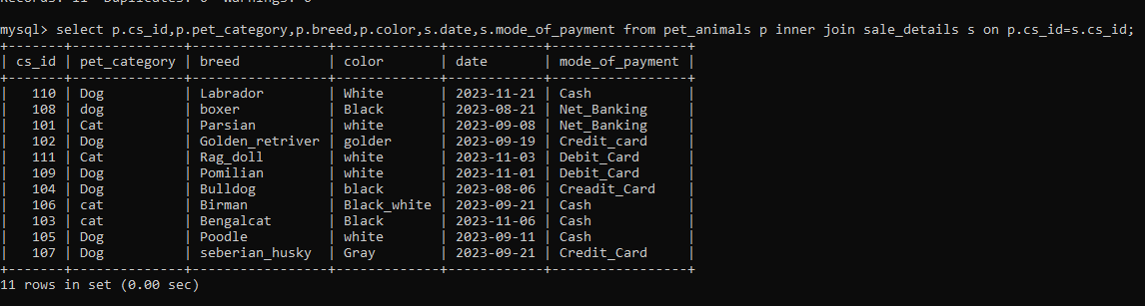

1. **LEFT JOIN**

* **QUESTION= Display the details of pet animals and pet sale details those table to join using LEFT joint.**
* **QUERY= select p.cs_id,p.pet_category,p.breed,p.color,s.date,s.mode_of_payment from pet_animals p left join sale_details s on p.cs_id=s.cs_id;**

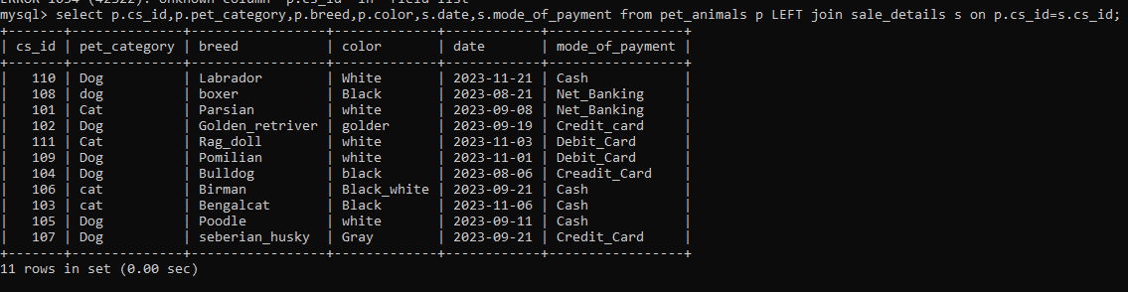

1. **RIGHT JOIN**

* **QUESTION= Display the details of pet animals and pet sale details those table to join using right joint.**
* **QUERY== select p.cs_id,p.pet_category,p.breed,p.color,s.date,s.mode_of_payment from pet_animals p right join sale_details s on p.cs_id=s.cs_id;**

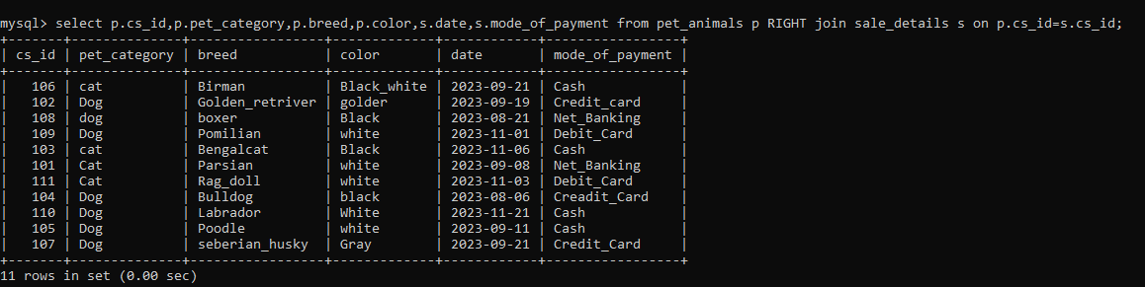

1. **SELF JOIN**

### QUESTION=Display pet seller Using self join to query hierarchical data for seller table.

* **QUERY=select concat ( d.se_firstname,’ ‘,d.se_lastname)as fullname,concat(p.se_firstname,’ ‘,p.se_lastname)as manager from pet_seller d,pet_seller p where d.mid=p.se_id;**

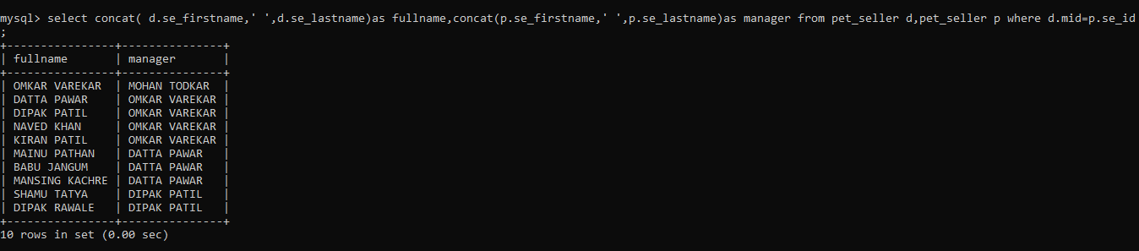

1. **CROSS JOIN**

* **QUESTION=Display the details of pet animals and pet sale details those two table are cross join for pet breed,color and sale date they cross join for sale details id.**
* **QUERY=SELECT P.BREED,P.COLOR.S.SD_ID,S.DATE FROM PET_ANIMALS P CROSS JOIN SALE_DETAILS S;**

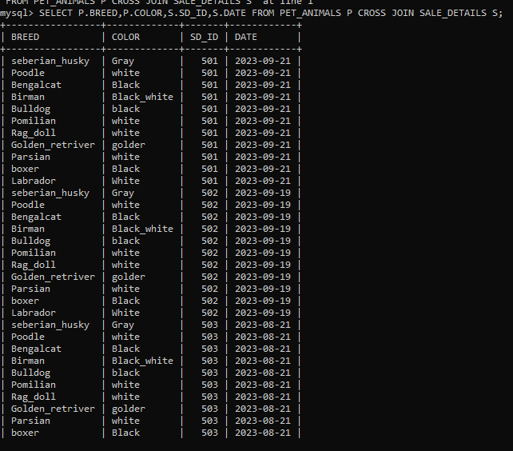

**SUB-QUERIES**

* **QUESTION**= Display the details of seller the salary greater than to average salary for seller and this seller designation for manager**.**
* **Query=**SELECT * FROM PET SELLER WHERE SE SALRY FOR MONTH> (SELECT AVG(SALARY) FROM PET SELLER) AND DESIGNATION=(SELECT DESIGNATION FROM PET SELLER WHERE DEGIGNATION=’MANAGER’);

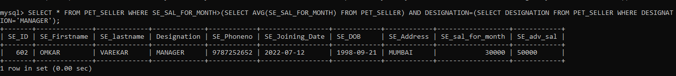

* **QUESTION=Display the details of all the seller who earns salary LESS than the 4th highest salary**
* **QUERY=Select * from pet seller<= (select max(salary) from pet seller where salary <(select max(salary) from pet seller where salary<(select max(salary) from pet seller where salary<(select max(salary) from pet seller))));**

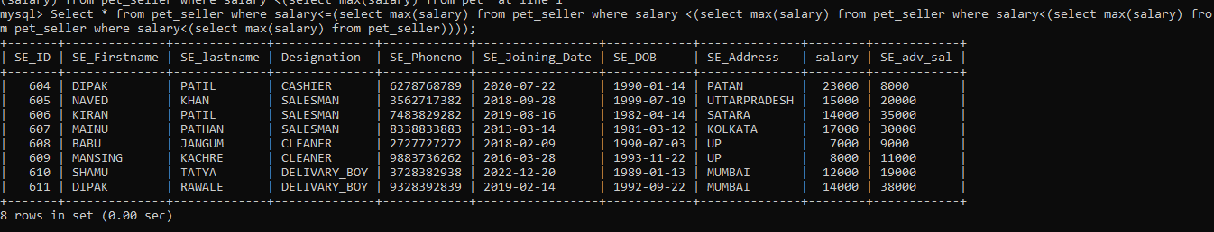

* **QUESTION=Display the details of pet seller who else works in the same position as ID=607?**
* **QUERY=select * from pet seller where designation=(select designation from pet seller where se id=607);**

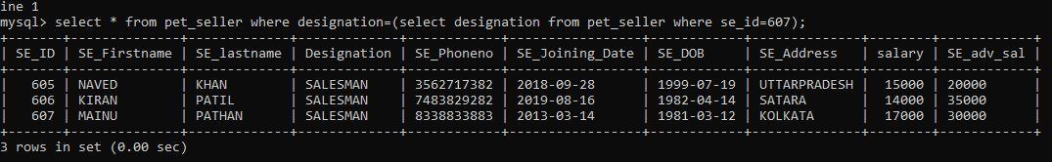

* **QUESTION=** **Display the details of pet animal who has 2nd highest cost.**
* **QUERY= select * from pet animals where cost=(select max(cost) from pet animals where cost<(select max(cost) from pet animals));**

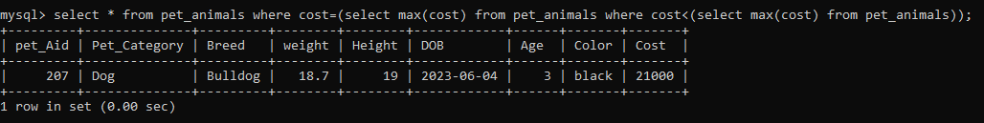

**OTHER FUNCTION’S AND STATMENT’S**

* **DISTINCT**
* **QUESTION=Display the pet birds table what are the type for display unique data,**
* **QUERY=select distinct(type) from pet birds;**

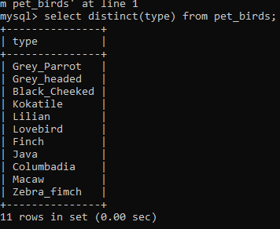

* **CONCAT**
* **QUESTION=Display the pet customer table for full name of pet customer show to id=106.**
* **Query=select pet cs id, concat (first name,’ ‘, last name) as full name, call whp number as from pet customer where cs id=106;**

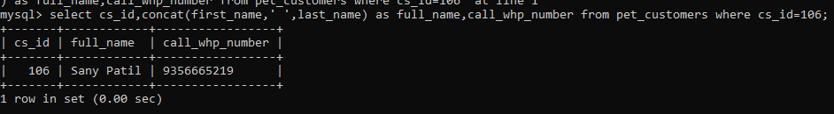

* **UNION**
* **QUESTION=Display the details of pet bird and pet product this is add by to only one table.**
* **QUERY=select * from pet birds union select * from pet products;**

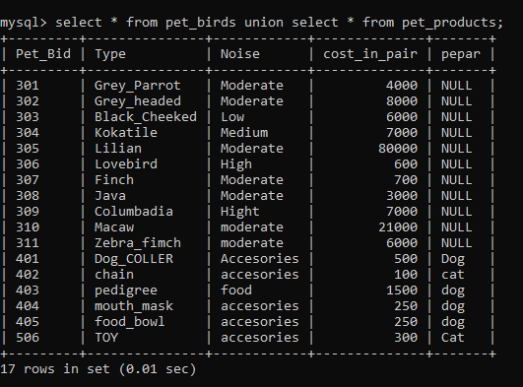

* **DROP TABLE QUERY:**
* **QUERY= DROP TABLE TbNAME;**
* **DROP DADABASE:**
* **QUERY=DROP DATABASE DATABASE NAME;**
* **TO ADD NEW COLUMN:**
* **ALTER TABLE TBNAME ADD NEWCOLUMNNAME DATATYPE(SIZE,ex.VARCHAR,CHAR,INT );**
* **TO ADD NEW COLOMN AFTER COLOMN NAME:**
* **ALTER TABLE TBNAME ADD NEWCOLUMNAME DATATYPE(SIZE,ex.VARCHAR,CHAR,int)**

**->AFTER COLOMN NAME;**

* **TO DROP COLOMN:**
* **ALTER TABLE TABLENAME DROP COLOMN COLOMNNAME;**
* **TO CHANGE COLOMN NAME:**
* **ALTER TABLE TABLENAME CHANGE COLOMNNAME NEW COLOMNNAME DATATYPE(INT,VARCHr,char);**
* **TO CHANGE TABLE NAME:**
* **ALTER TABLE TABLENAME RENAME TO NEWTABLENAME**
* **TO CHANGE DATATYPE:**
* **ALTER TABLE TABLENAME MODIFY COLOMNAME DATATYPE(INT,VARCHAR);**
* **TO TRUNCATE TABLE:**
* **TRUNCATE TABLE TABLENAME;TIP ONLY DELETED BY TABALE SRTUCTURE,**